Reading your Direct Service Profile Report
in the ECE Workforce Registry
The Direct Service Profile Report (DSPR) is for Training Organizations who are State Funded Vendors. CCIP and R&R training activities are required by the CDE to be entered in the Registry.
This report is an auto-generated export of Registry data for the Child Development Training Consortium (CDTC) reporting to the California Department of Education – Early Learning and Care Division.
Data Entered in to the Registry:
Training and participant data makes up the fields in the DSPR.
- Training organizations enter training data into the Registry which includes creating a Training description and a training Event (with logistical information).
- ECE Professional Participants self-report demographic data and submit educational and credential documents in the Registry.
Pulling the DSPR:
Login to your Registry profile.
Click on Training Sponsor Tools (you must already have Training Sponsor access, if not, contact your training organizations Registry contact manager).
Select Reports and then select Direct Service Profile Report - Training Orgs – CDTC
Select data filters: program codes, dates, counties
Report will download in Excel (click on “Enable Editing”)
Reading the DSPR fields:
Column A is the Organizational Code, ORGCODE. This code is made up of six pieces of information and includes:
- Vendor Number - this is the training organizations state vendor number
- CDE/F5CA Program Code - county number + Program Code (e.g. CCIP, R&R, HST, Bridge, Strengthening Families, PHS)
- Delivery Type – peer to peer (0), training (1), TOT (2), TA (3), Coaching (5), Mentoring (6)
- Delivery Method (classroom or online)
- CDE/F5 Funded (0) or Fee-for Service (8)
For example - TEST##C100
Test Organization – County – CCIP – Training – Classroom – CDE Funded
Columns B and C show training name and date. All other data is participant data and the fields are described on the Data Dictionary and Data Entry Instructions for the Confidential Profile For Direct Service Participants
Creating a pivot table to organize DSPR data:
Including organizational code, training names, dates, and attendee numbers (see example below).
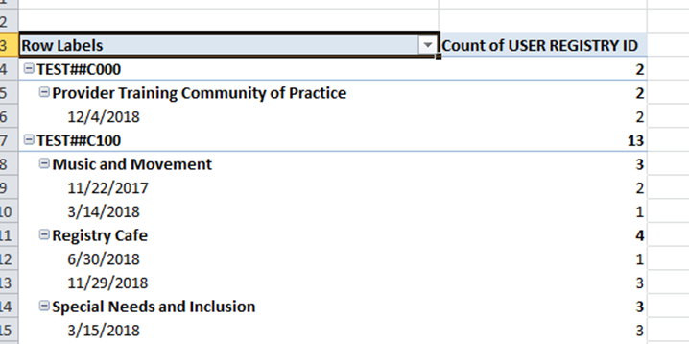

1. Highlight all data on the spreadsheet
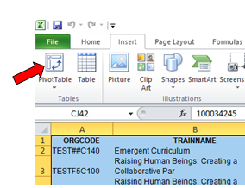
2. Select Insert on the toolbar and click on Pivot Table

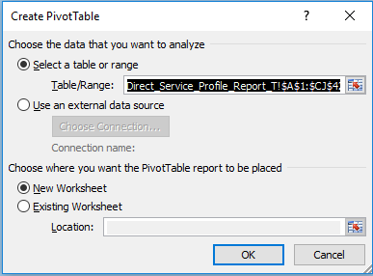
3. It will ask if you want a New Worksheet and you can click OK

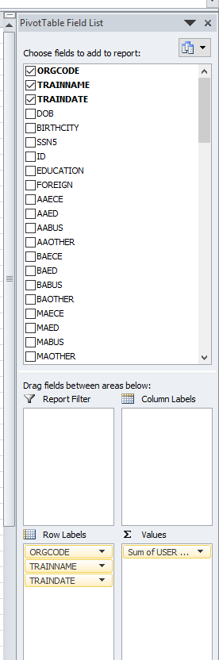
4. On the right hand side of the Pivot Table screen, select the top three: ORGCODE, TRAINNAME, TRAINDATE and at the very bottom of Pivot Table Field List, select USER Registry ID into the Values box (see image to the right)
5. Click on the dropdown of the “Sum of USER REGISTRY ID”, click on “Value Field Settings”, click on Count and OK
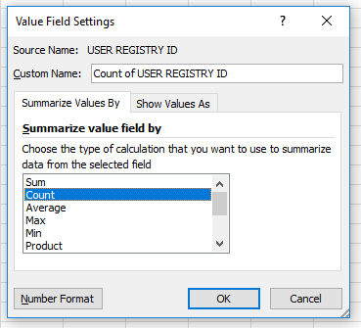

6. Copy the table into a Word document so you can easily make edits and customize the headings and remove the duplicate data from the Training name and date fields.
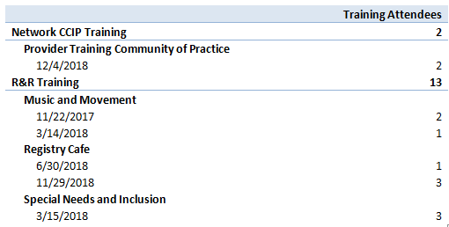
Tips for entering data:
Training Types:
When you enter an Event make sure that when you select the intended audience that you only enter who the training was designed for – NOT everyone who attends the training. If a training organization offers a training for Family Child Care Providers and Prospective Providers, for example, and you select “Trainer”, this training will be reported to the CDE as a “Train the Trainer” instead of a “Training”.
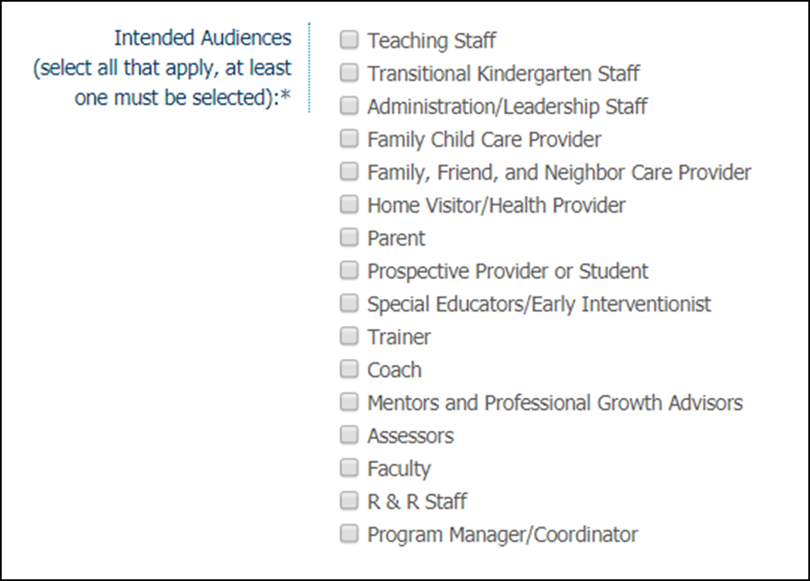
Updating Participant Profile:
To help guide ECE Professionals with updating their ECE Registry profile have them login into their Registry profile and click on the Quick Links View Update Profile or My Profile and make edits on the Profile Editor. Update personal information, employer, educational, and demographic data. To have self-reported documents verified submit on My Documents.

